Warner Robins High School

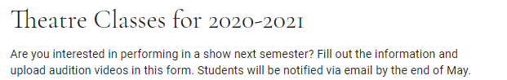

Please use this link to submit your audition videos.

https://forms.gle/gHE4RwhFJinFCEgHA

There are three classes students can sign up/audition for:

- Fundamentals of Theatre is an intro class that focuses on stage basics, acting, history of theatre, and playwriting.
- Children's Theatre (Advanced Drama) performs one play and/or musical per semester for elementary school students during the school day. Normally, there is one play and one musical. After school rehearsals are limited to two weeks each semester. Examples of shows performed by this class: Charlotte's Web, Miss Nelson is Missing, Fancy Nancy, A Charlie Brown Christmas.
- One Act (Musical Theatre) performs the traveling competition musical in the fall and works with the big musical in the spring. Fall semester after school rehearsals are most days Mid August-Mid November. Examples of shows performed by this class: Freaky Friday, The Wiz, 42nd Street, 25th Annual Putnam Co. Spelling Bee.

