SES Library News

Fall 2016

**Open Check-Out**

Open check-out started recently and has been a big hit with our students. Students are allowed to visit the library each morning with a pass from their teacher. This allows students to get books even if it’s not their library day. The more books we put in our kids hands, the more they will read.

Have you visited our Library Website?

[www.desotocountyschools.org/ses](http://www.desotocountyschools.org/ses)

Go to our school website to visit our Library web page. There you can find lots of cool links for kid friendly researching, reading online, and games. Have you been on Epic? This is great site that is free through a school login. A login can be given from your child’s teacher or from the library.

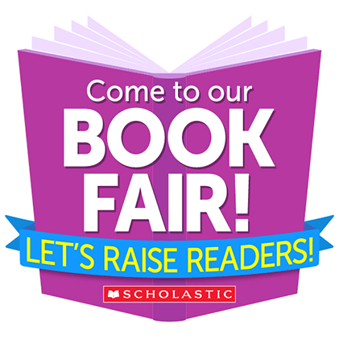

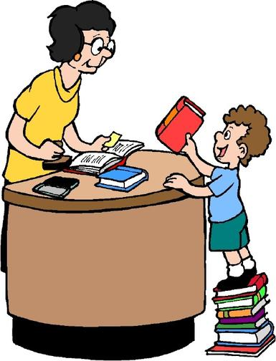

Mark your Calendars!

Our Scholastic Book Fair will be October 31 – November 4. We will be open daily in the library that week. You are welcomed to shop with your child with a visitor’s pass. We would love to see you at our Parent Night that week also. Look for more information coming home soon.

**Reading Fair**

The SES Reading Fair will be held in December. Students in all grades may participate in the reading fair. This year’s fair will be completely optional so no project boards will be provided by the school. A note with more information will come home soon.

continued from page 1

continued from page 1