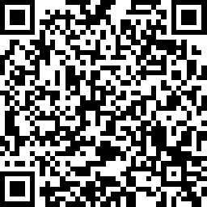
Scan this QR Code to take our Parent Involvement Survey

