Name___________________________ Chapter Four
Test review

1. When a family with two adults and three children bought tickets for an amusement park, they paid a total of $56.50. The next family in line, with four children and one adult, paid $49.50. Find the adult and child prices.
Define your variables, and write two equations to represent the given information in
this situation and solve using any method. 10 points
______________________________________________________________________________
______________________________________________________________________________
______________________________________________________________________________
______________________________________________________________________________
______________________________________________________________________________

2. Given the line y = -3x +b passes through the point (-3, -1). What is b?

Solve for x:
3. (x + 4)(x + 3) = (x + 2)(x + 1) 4. $\frac{2}{3}x+7=\frac{-1}{5}x+3$

5. I have two equations, Equation A and Equation B. When I graph these two lines I only see one line. What can you tell me about the equations of line A and line B?
______________________________________________________________________________
______________________________________________________________________________
______________________________________________________________________________
6. I have two more equations, Equation C and Equation D. When I graph these two lines they are parallel. What can you tell me about the equations of line C and line D?
______________________________________________________________________________
______________________________________________________________________________
Solve each system below using whatever method you prefer. Show all work!

7. 4x – 3y = -10 8. 4x + 5y = 11
x = $\frac{1}{4}$y - 1 2x + 6y = 16

9 a) Henry’s potato vine is growing like crazy! When he planted it, it was 7 inches long. Two weeks later, it was 14 inches long. Two weeks after that, it was 21 inches long. Graph this data and write an equation to represent this situation. Make sure you label your axes!!!

b) Bernice also planted a potato vine the same time Henri did, and Bernice’s vine’s length follows the equation y= 2x + 5. Will their two vines ever be the same length? How do you know? Explain.

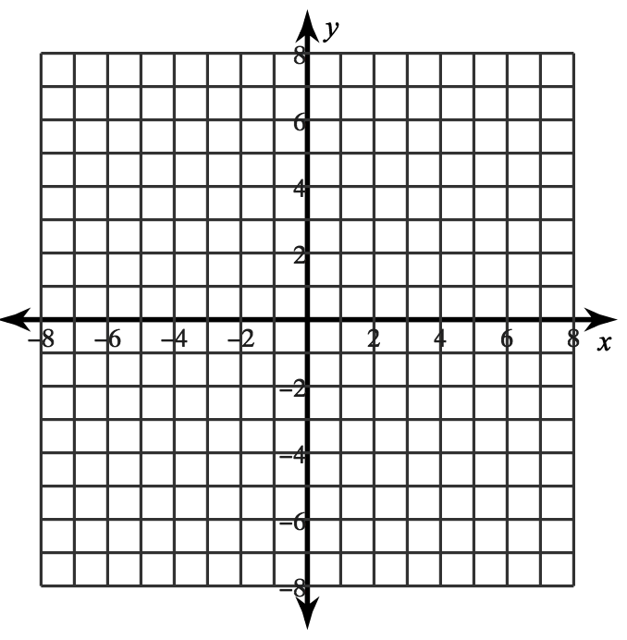
11. Solve this equation for y: 3x − 2y = -8

12. a. Graph the system of inequalities on the graph given.

2x + y > 5
y ≤ 1/3 x− 1

13. Leah would like to earn at least $120 per month. She babysits for $5 per hour and works at an ice cream shop for $8 per hour. Leah cannot work more than a total of 20 hours per month. Let x represent the number of hours Leah babysits and y represent the number of hours Leah works at the ice cream shop.

a. Write a system of inequalities that will represent the problem: 1._______________________

b. Graph this system below: 2. ______________________
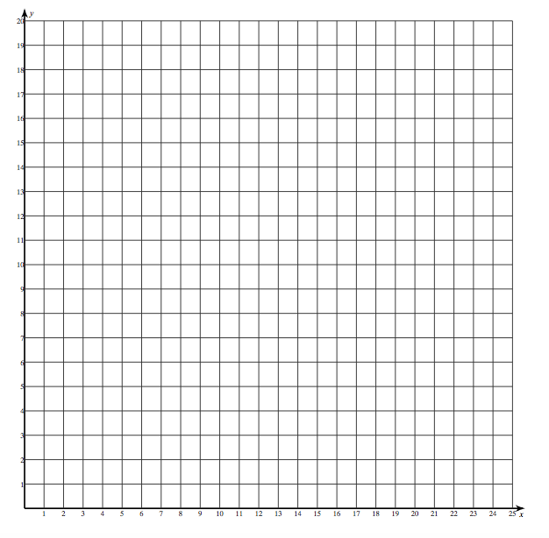

c. inequality # 1 x-intercept __________

y-intercept __________

d. inequality # 2 x-intercept __________

y-intercept ____________

13. Write an equation for a line that has a slope of $\frac{4}{3}$ and passes though (-3, -3).

14. Write an equation for a line that passes through (4, 4) and (3, -2).

15. Identify the following functions as even, odd, or neither.
a. $f\left(x\right)=x^{2}+x^{4}-x^{6}$ b. $f\left(x\right)=2x+5$

c. $f\left(x\right)= {10x}^{3}-{4x}^{2}+3x-8$ d. $f\left(x\right)={2x}^{5}+{3x}^{3}-x$

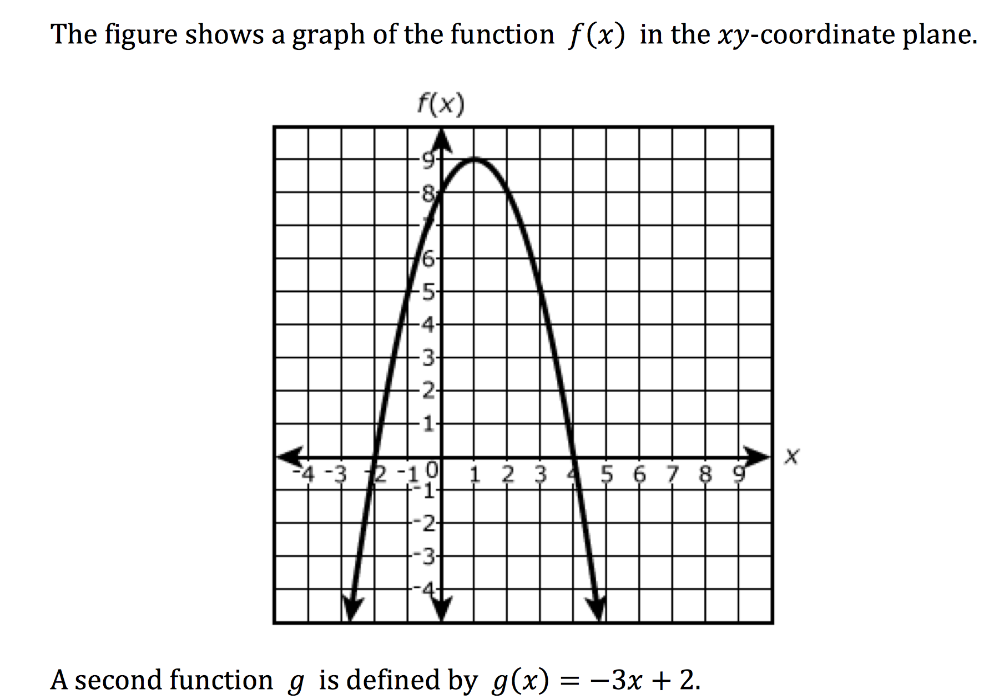
17.

Circle the correct answer for each question: 3 points each
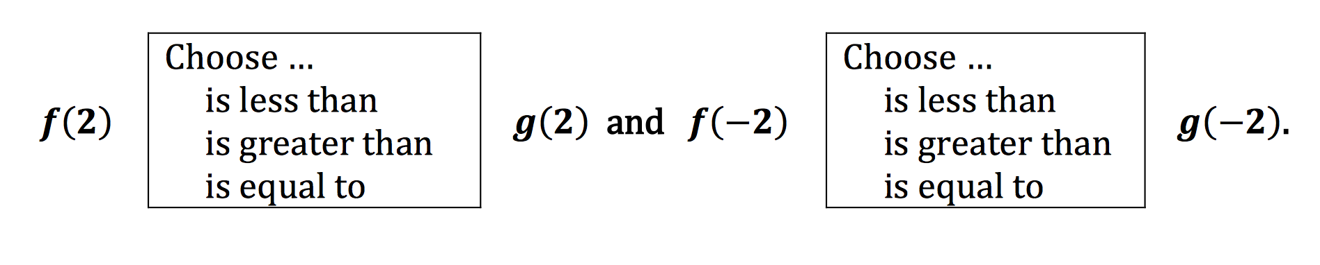

Simplify the following:

18. $6x(3x^{4}-3x^{3}+6)$ 19. ${\left(3x-5\right)}^{2}$

20. $\left(4x-5\right)\left(4x+5\right)$ 21. $\left(2x-7\right)\left(x+4\right)$

