**F**

**O**

**R**

**C**

**E**

**&**

**M**

**O**

**T**

**I**

**O**

**N**

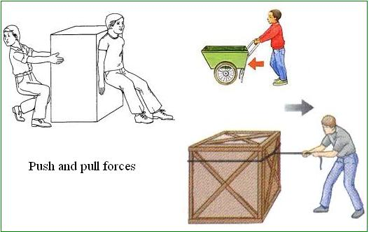

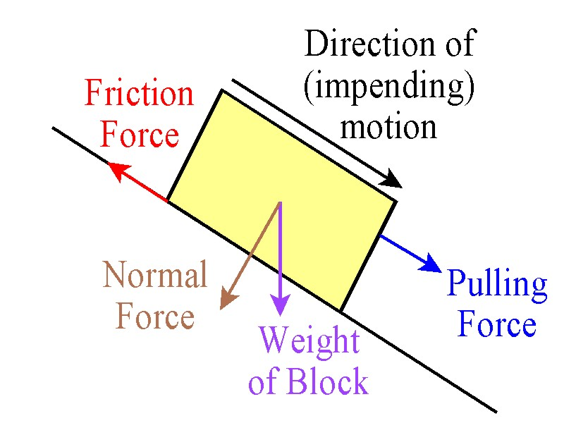

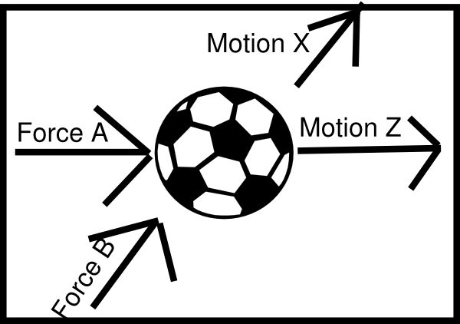

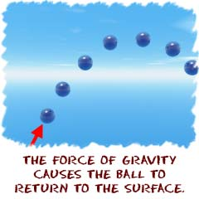

26. Sir Isaac Newton’s Laws of Motion are three physical laws which provide relationships between the forces acting on a body and the

motion of the body.

27. **equal forces** acting on one object in opposite directions create balanced forces.

28. **balanced forces** result in an object remaining at rest or moving at a constant velocity.

29. where there is a net force acting on an object, the forces are said to be **unbalanced**.

30. unbalanced forces cause changes in velocity.

31. **energy** is the ability to do work and without energy, forces can’t be generated to make things move or change.

32. regardless of their complexity, all machines are in some way(s) based on simple machines.

33**. simple machines** are all around us and make work **easier**.

34. simple machines are “simple” because most only have one moving part.

35. gravity, friction, and inertia **affect** simple machines.

36. a **complex/compound** machine is made up of **two or more** simple machines.

**The students will understand that…**

1**. motion** is a change in position.

2. an object is in **motion** when its distance from another object is changing.

3. a **reference point** is a **fixed point** for comparison.

4. motion is measured by measuring distance.

5. **friction** is the force that opposes motion when one object comes in contact with another.

6. speed, velocity, and acceleration are **different** concepts.

7**. speed** is a measure of **how quickly** the position of an object changes.

8. **velocity** is the **speed** of an object in a **certain direction** (vector).

9. **acceleration** is **the increase in velocity** divided by the time it takes for the change to occur.

10. acceleration occurs whenever there is a change in motion of an object.

11. **acceleration** can involve a change in speed and/or direction.

12. acceleration is caused by net forces.

13. there are mathematical relationships between speed, velocity, acceleration, and time that can be used to help understand motion.

14. acceleration measures the rate at which an object’s velocity changes with time and can be written as a positive or negative number.

15. the velocity of an object describes both the speed of an object, the direction the object is traveling and can be written as a positive or

negative number.

16. the average speed (rate of motion) of an object is the distance traveled by the object divided by the time it takes to travel that distance.

17. every object exerts a **gravitational force** on every other object.

18. an object’s size (mass) and the amount of force exerted on it affect its speed and direction.

19. gravity refers to the force of attraction between two objects in the universe that have mass.

20. the force of gravity acts between all objects in the universe (law of universal gravitation).

21. the **strength of the force of gravity** depends on the **mass** of the objects and the **distance** between them.

22. **forces are pushes or pulls in nature** produced by interactions between objects.

23. **forces** can cause objects to start moving, stop moving, or change direction.

24. the combination of all the forces acting on an object is the **net force**.

25. objects tend to keep doing whatever they are doing (**Law of Inertia**).