NAME

HAP 6.1 NERVOUS SYSTEM WORKSHEET

1. The diagram below is of a nerve cell or neuron. Add the following labels to the diagram:
Period

Axon Myelin sheath Cell body Dendrites Muscle fibers Axon terminals

2. Color in the diagram as suggested below.

Axon - purple Axon Terminals – orange Myelin sheath – yellow

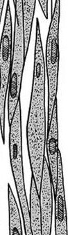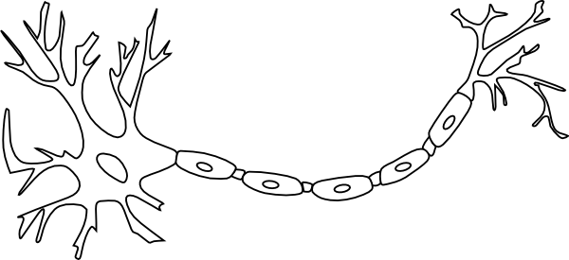Cell body – blue Dendrites – green Muscle fibers - red

3. There are three different kinds of neurons or nerve cells. Match each kind with its function.

A. Motor neuron B. Sensory neuron C. Relay neuron;

Kind of neuron Function

...................................
The nerve cell that carries impulses from a sense receptor
to the brain or spinal cord.

.................................... The nerve cell that connects sensory and motor neurons

.....................................
The nerve cell that transmits impulses from the brain or spinal cord to a muscle or gland
3. Match the descriptions in the table below with the terms in the list.

A. Synapse B. Axon C. Myelin sheath D. Nerve impulse E. Sense receptor F. Response; G. Reflex H. Cell body I. Dendrite J. Nerve K. Neurotransmitter L. Axon terminal
Term Description

.............................. 1. The long fiber that carries the nerve impulses.

.............................. 2. A bundle of axons.

.............................. 3. The connection between adjacent neurons.

............................... 4. The chemical secreted into the gap between neurons at a synapse.

............................... 5. A rapid automatic response to a stimulus.

............................... 6. The covering of fatty material that speeds up the passage of nerve impulses.

................................... 7. The structure at the end of an axon that produces neurotransmitters to transmit the nerve impulse across the synapse.

................................ 8. The high speed signals that pass along the axons of nerve cells.

................................ 9. The branching filaments that conduct nerve impulses towards the cell.

..................................... 10. The sense organ or cells that receive stimuli from within and outside the body.

..................................... 11. The reaction to a stimulus by a muscle or gland.

..................................... 12.The part of the nerve cell containing the nucleus.

4. Indicate whether the following parts of the nervous 5. Label and color the 3 major parts of the brain. system are part of the Central Nervous System CNS) or Cerebrum – Red Cerebellum – Blue
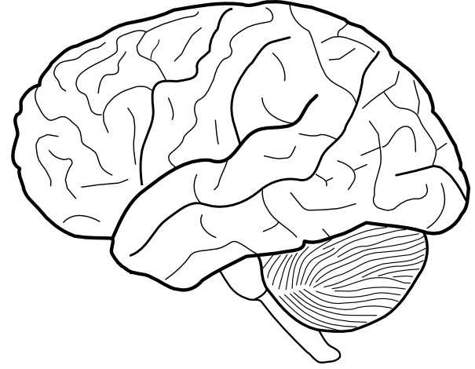the Peripheral Nervous System (PNS). Brain Stem - Yellow Part of nervous system CNS or PNS?
Brain ........................ Autonomic nervous system ........................ Spinal nerves ........................ Spinal cord ........................ Cranial nerves .........................

