March 16th Kindergarten Goal Sheet
Phonics/ Language Arts
Students will be able to read sight words learned to date.
Students will be able to read short sentences.

Handwriting
Students will be able to write with correct letter formation.
Students will be able to write with correct sentence structure.

Numbers/ Math
Students will be able to display number sense.

Social Studies/ Science
God’s Creation, Citizenship

Bible
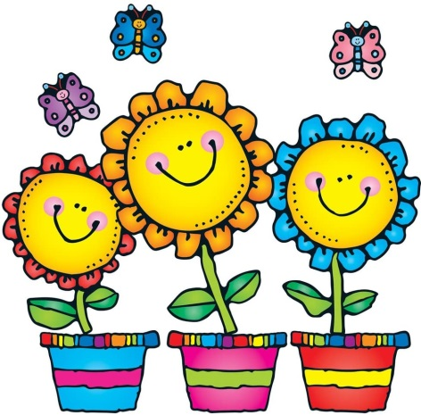
King Solomon, Fruit of the Spirit

