Name: __________________________________________ Period: __________
HAP 6.1 HOMEWORK NERVOUS SYSTEM

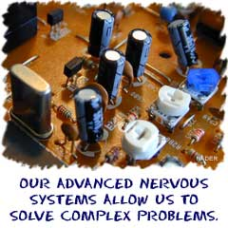
Nervous System - I'm Sensing Something
Since you're reading this page, we figure you've got a nervous system. If you were an insect you would also have a nervous system, but it would be a lot simpler. Even animals that don't think have simple nervous systems called nerve nets that help them move.

What Does This System Do?
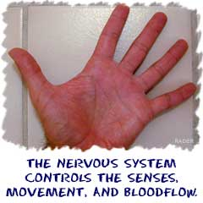
If you see a bike that might hit you, you jump out of the way. In that example, your nervous system was involved in many ways. Your eyes saw the bike, your brain figured out the bike might hit you, and your brain told your muscles to make your legs jump out of the way. You sensed and then acted. The nervous system also senses activity inside of your body. Most of the nervous system response inside of your body is not in your control. So controls and coordinates the actions of all organs and organ systems. Your body automatically senses and reacts to stimulus. Think about eating your lunch. As you eat, your nervous system triggers the start of digestion and release of many hormones and enzymes throughout your body. It helps
To monitor, respond and adapt and to changes in external and internal environments.

Interacting with Other Systems
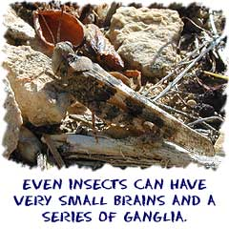
Your nervous system interacts with every other system in your body. In the same way that all of your cells need oxygen transported by the circulatory system, all of your tissues and organs require instruction and direction from the nervous system. There is obvious interaction between your muscles and your nervous system. That interaction helps you move around and interact with your environment.
There are many hidden interactions going on within your body. Your endocrine system works closely with your brain and central nervous system to control the creation of specific hormones and enzymes. Your digestive and excretory systems work with the nervous system in both conscious and unconscious ways. While digestion goes on without your thoughts, eating, peeing, and pooping are under your control.
Now answer the questions
- You can read and understand para because of ……………………………………………………. (system)
- Insects have simpler nervous system but we …………………………………………………………………….
& this the reason ……………………………………….. (insects/humans) cannot have aptitude
- FUNCTIONs: -_________________ and ___________________ the actions of all organs and
organ systems.
- To _________, ____________ and ________________ to changes in external and internal environments. In short: Monitors and responds to stimuli in the environment.
Cite THREE daily life examples of functions of nervous system.

- In order to complete its normal role, it has three overlapping functions. List and explain each.

  - Sensory Input – __________________________________________________________________
______________________________________________________________________

  - Integration – ______________________________________________________________________
________________________________________________________________________

  - Motor Output – ____________________________________________________________________
________________________________________________________________________

  - The nervous system is mainly made up of _________________ tissue. These specialized cells are called __________________________. It’s job is to ___________ and _____________________ messages.
  - The nervous system consists of two main parts.
________________________________________ | ______________________________________
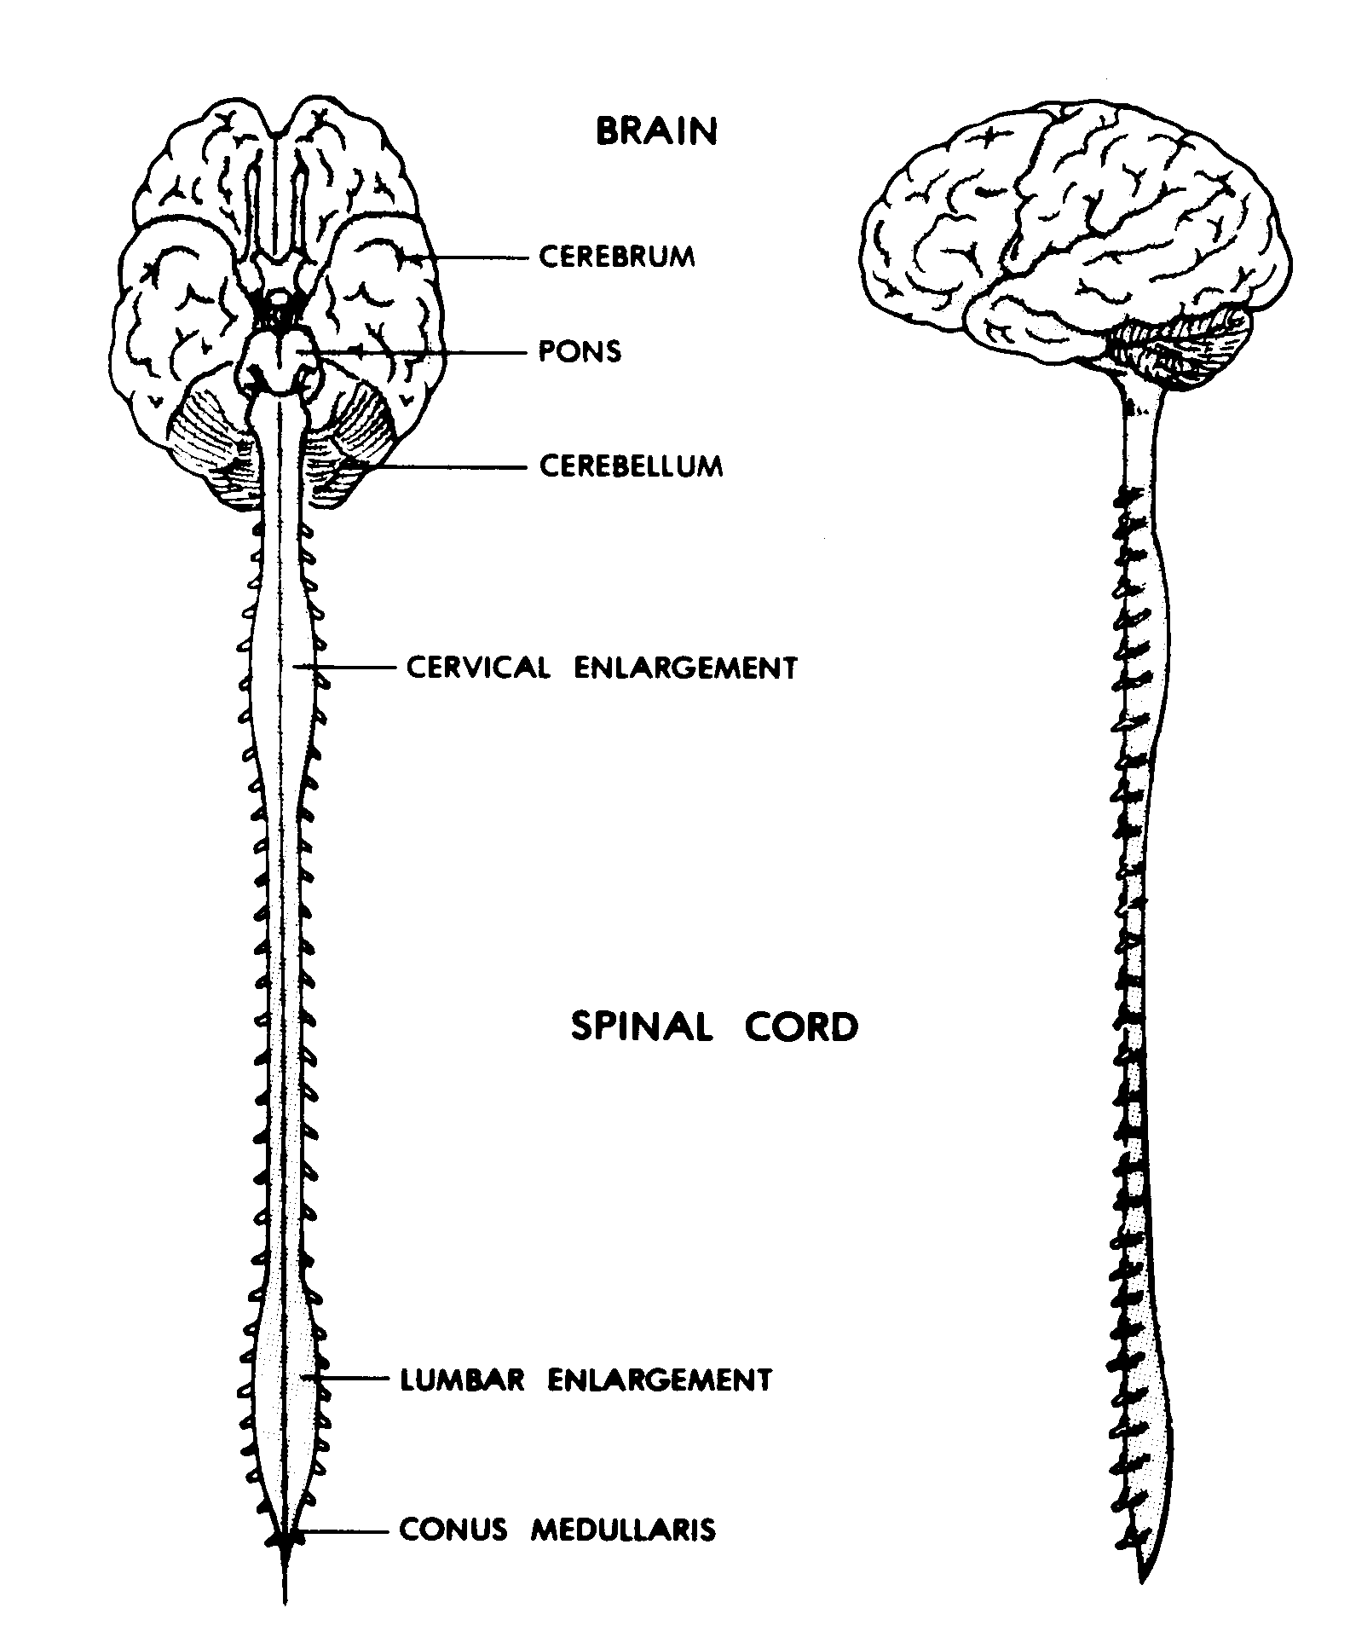  Consists of the brain and spinal cord | 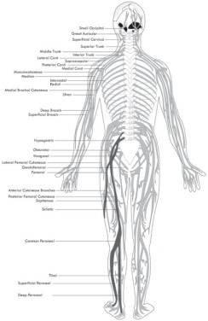  Made up of cranial (head) and spinal nerves
  - Label and color the diagram using red for the central system and blue for the peripheral system.
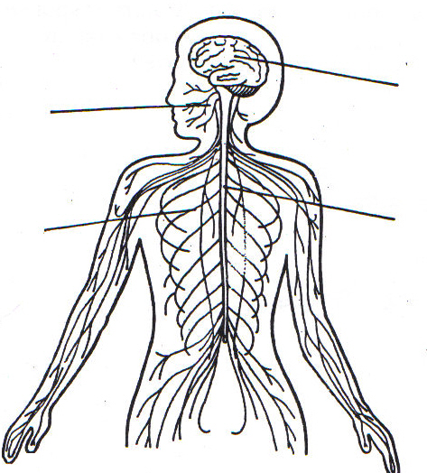

There are two types of cells in the peripheral nervous system. These cells carry information to (sensory nervous cells) and from (motor nervous cells) the central nervous system. Cells of the sensory nervous system send information to the CNS from internal organs or from external stimuli. Motor nervous system cells carry information from the CNS to organs, muscles, and glands.

Somatic and Autonomic Systems
The motor nervous system is divided into the somatic nervous system and the autonomic nervous system. The somatic nervous system controls skeletal muscle, as well as external sensory organs, such as the skin. This system is said to be voluntary because the responses can be controlled consciously. Reflex reactions of skeletal muscle, however, are an exception. These are involuntary reactions to external stimuli.The autonomic nervous system controls involuntary muscles, such as smooth and cardiac muscle. This system is also called the involuntary nervous system. The autonomic nervous system can further be divided into parasympathetic, sympathetic, enteric divisions.The parasympathetic division functions to inhibit or slow down autonomic activities such as heart rate, pupil constriction, and bladder contraction. The nerves of the sympathetic division often have an opposite effect when they are located within the same organs as parasympathetic nerves. Nerves of the sympathetic division speed up heart rate, dilate pupils and relax the bladder. The sympathetic system is also involved in the flight or fight response. This is a response to potential danger that results in accelerated heart rate and an increase in metabolic rate.
The enteric division of the autonomic nervous system controls the gastrointestinal system. It is composed of two sets of neural networks located within the walls of the digestive tract. These neurons control activities such as digestive motility and bloodflow within the digestive system. While the enteric nervous system can function independently, it also has connections with CNS allowing for the transfer of sensory information between the two systems.

Division
The peripheral nervous system is divided into the following sections:
- Sensory Nervous System—sends information to the CNS from internal organs or from external stimuli.
- Motor Nervous System—carries information from the CNS to organs, muscles, and glands.
  - Somatic Nervous System—controls skeletal muscle as well as external sensory organs.
  - Autonomic Nervous System—controls involuntary muscles, such as smooth and cardiac muscle.
    - Sympathetic—controls activities that increase energy expenditures.
    - Parasympathetic—controls activities that conserve energy expenditures.
    - Enteric—controls digestive system activity.

Connections
Peripheral nervous system connections with various organs and structures of the body are established through cranial nerves and spinal nerves. There are 12 pairs of cranial nerves in the brain that establish connections in the head and upper body, while 31 pairs of spinal nerves do the same for the rest of the body. While some cranial nerves contain only sensory neurons, most cranial nerves and all spinal nerves contain both motor and sensory neurons.
  - THE PERIPHERAL NERVOUS SYSTEM: The peripheral nervous system is divided into two types of neurons.
___________________ neurvous system | _______________________
carry information from body to the central nervous system. | carry information from the central nervous system to the muscles or organs.

7. The peripheral nervous system can be either
- ___________________nervous system: where you have conscious control over your responses to stimuli, like _______________________________________________.
- ____________________nervous system: an unconscious response to stimuli. Known as an automatic response (you do not think about it) is controlled by the __________________ nervous system like __________________________________.

