Preventive Practices
Practicing Prevention  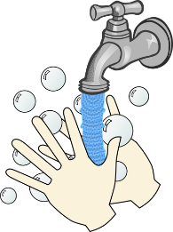 | • Ecovasive cleaning will be completed every 90 days.  • Teach and reinforce good hygiene measures such as handwashing, covering coughs, and wearing face coverings (optional).  • Provide hand soap, hand sanitizer, paper towels, and no-touch trash cans in all bathrooms, classrooms, and frequently trafficked areas.  • Clean/disinfect frequently touched surfaces at least daily and shared objects after use.  • Students are required to bring their own water bottles. No water bottles will be provided during the school day. Water bottles may be refilled as needed at school.  • Ensure ventilation systems operate properly and increase circulation of outdoor air as much as possible, as long as this does not pose a safety or health risk to students or staff.

Transporting Students
School Bus Safety  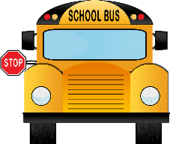 | Bus Drivers and Monitors  • All drivers and monitors are strongly encouraged to wear face masks and gloves at all times.  • Clean and disinfect the bus before pick-up and after drop-off.  • Keep bus windows open for proper ventilation, weather permitting.  • Issue hand sanitizer.  Students  • Students are encouraged to wear a face mask/covering at all times before, during, and after the bus ride.  • Sanitize hands before entering the bus.

Entering and Exiting School Buildings/Transitioning
School Day Protocols  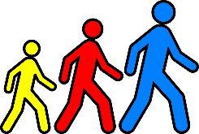  School Day Protocols | Visitors (including Parents)  • Visitors will be permitted to enter the campus when formally approved by school administration.  • Campus access shall only be permitted through the front office.  • Masks are requested but not mandatory for visitors.  • Visitors must undergo the standard sign-in protocols.  Students  • Use of face coverings/masks is not mandated but is strongly recommended.  • Hallways and high-touch surfaces will be cleaned throughout the school day.  End of School Day Dismissal  • Students must sanitize their hands before boarding school buses.  • Students identified for targeted assistance, student support, or afterschool programs must be issued an afterschool pass.

Serving Meals
Breakfast  and Lunch  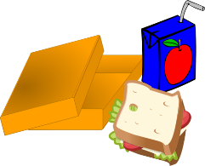 | • Students are encouraged but not required to wear a face mask/covering enter the cafeteria, in line at hand cleansing stations, and in line for foodservice.  • Students must not share food or utensils.  • Cafeterias and high-touch surfaces will be cleaned throughout the school day.

Safety Protocols
Safety Protocols  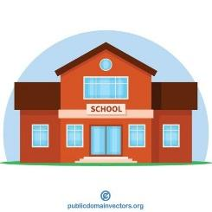 | Sick Person or Positive Cases  • Administrators will immediately notify the Director of Student Services.  • The Director of Student Services will notify the local health officials.  • These officials will coordinate with the Director of Student Services to determine a course of action for the classroom and/or school.  • Anyone who was in class with the affected person and was directly exposed (within 6 feet for 15 continuous or cumulative minutes) will be segregated by remaining in place or brought into an isolation area.  • Identified unvaccinated persons will be sent home to self-monitor for 7 days with a negative test (test taken after day 5) or 10 days without testing.  • The school office will inform parents of those students affected and update them regarding any changes in conditions.

Special Populations
Program for Exceptional Students | Special Education  • IEPs will remain in place; however, Distance Learning Plans will drive instructional supports and services.  Section 504  • Accommodation Plans will be reviewed to ensure all are up to date.  • Accommodations will remain in place regardless of instructional setting.

Conducting Large Group Gatherings
Fine Arts, P.E., Clubs, Recess, Media Centers, Athletics, etc. | Media Centers  • Media centers will be open for normal classroom activities and general browsing.  • All books will be disinfected upon return in accordance with government guidelines.  Recess, Afterschool Clubs, Band, Art, Chorus, etc.  • Students will be required to bring refillable bottles for water.  • Water fountains will be equipped with gooseneck faucets to refill bottles.  • Students must not share bottles.  Athletics  • Guidelines are implemented for the protection of all athletes, coaches, athletic training and other medical personnel, and affiliated support staff in accordance with current Governor’s Office, Centers for Disease Control and Prevention (CDC), and Georgia High School Association (GHSA) guidelines and policies.  Links to GHSA information:  https://www.ghsa.net/  https://www.ghsa.net/infectious-disease-plan-information

