Unit 1: Structure and Properties of Matter Student Notes

- Matter
  - Matter is anything that has mass and takes up space.
    - Examples of matter include plants, animals, rocks, buildings, water, dust, and air.
    - Examples of things that are not matter include different forms of energy, emotions, thoughts, and dreams.

  - Composition of Matter
    - All matter is made up of tiny particles called atoms.
An atom is the smallest unit of matter that has all the properties of a given element.
    - (It would take approximately 1 million atoms lined horizontally to equal the thickness of a human hair.)

Pure Substance vs. Mixture

  - Matter can either be classified as a pure substance or a mixture.
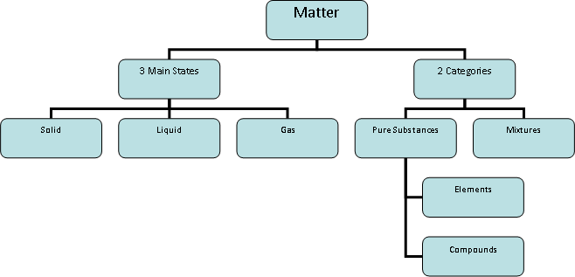

  - A pure substance is the same throughout (has uniform and definite composition). A pure substance can not be separated by physical means.
  - A mixture is not the same or not uniform throughout. Mixtures are made up of two or more things. Mixtures can be separated by physical means.

  - Elements and compounds are pure substances.
  - Elements are found on the periodic table and are made of one type of atom. Ex. gold, carbon, oxygen, silver. Do you recognize any other familiar elements?

  - Elements fall into three general categories characterized by similar properties: metals, nonmetals, and metalloids.
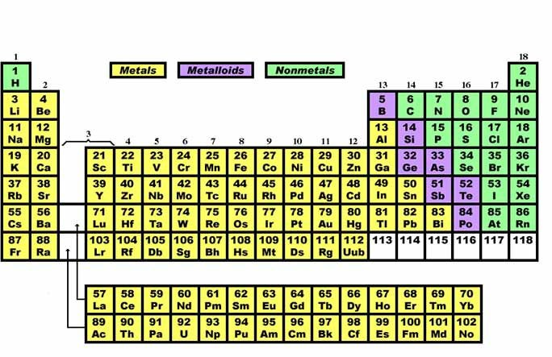

- Metals, which make up the majority of the elements, are found on the left side and middle of the periodic table. Properties of metals include:
  - Luster (shiny or good reflector of light).
  - Good conductor of heat and electricity.
  - Most are solids at room temperature.
  - Malleable- can be bent or pounded into various shapes or flattened into thin sheets (foil).
  - Ductile- can be drawn into wire without breaking.
- Nonmetals are found on the right side of the periodic table (except hydrogen). Properties of nonmetals include:
  - Dull (not shiny).
  - Poor conductor of heat and electricity.
  - Most are gases at room temperature.
  - Brittle- solids that crumble or break easily.
- Metalloids are found between the metals and nonmetals on the periodic table. They form the “stair step” line. Properties of metalloids include:
  - Have properties of both metals and nonmetals.
  - Are semiconductors (conduct heat and electricity under certain conditions).
  - All are solids at room temperature.

  - Compounds made when two or more elements chemically combine to form a new, pure substance. Ex. Carbon and oxygen react in a 2:1 ratio to form carbon dioxide (CO2).

States of Matter
  - Solids hold their shape, have definite mass and volume. Particles are packed tightly together and vibrate in place. Solids have low kinetic energy (and high potential energy).
  - Liquids take the shape of their container, have definite volume and
mass. Particles are more loosely packed than solids, vibrate, and can slide past each other. Liquids have higher kinetic energy than a solid , but less than a gas.
  - Gases have no definite shape or volume. They have definite mass. The particles are not touching, vibrate, and move freely to fill any space just by moving farther and farther apart. Gases have the highest kinetic energy (and lowest kinetic energy).
  - Plasma has no shape or volume. Particles have broken apart. Plasma particles are electrically charged. Ex. Lightning, Stars, Neon lights
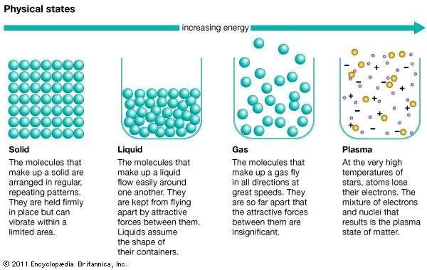

Interactive simulation on States of Matter: www.abcya.com/states_of_matter.htm
Note interaction:
Nathan measured an iron bar. He put the iron bar in the hot sun. When he measured the bar after it had been in the sun, it was slightly longer. Which sentence best describes what happened to the iron atoms after the bar was left in the hot sun?
- The amount of iron atoms in the bar increased.
- The size of the iron atoms increased.
- The space between each iron atom increased.
- The air in the spaces between the iron atoms expanded.
- Some of the iron atoms began to melt and spread out further in the bar.
- The heat caused some of the atoms to flow around the bar and pushed it outward.

- Change in State
Phase Changes https://www.youtube.com/watch?v=EZHmUTmJtF8
Phase Changes Exothermic or Endothermic https://www.youtube.com/watch?v=0cUK4jcAEaU Heating Curves https://www.youtube.com/watch?v=h9bUlvkeifU
  - All matter can move from one state to another with a change in temperature of pressure.
  - A heating curve (or cooling curve) show the change in phase in matter as thermal energy is added (or removed).
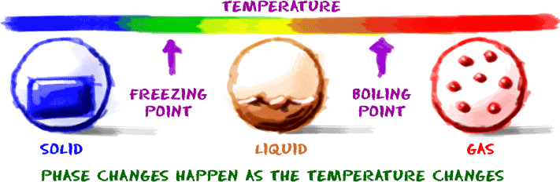
  - Changes in state are also known as phase changes.
  - Melting – going from a solid to a liquid. Must have an increase in energy. The molecules absorb thermal energy from the surrounding environment. This is an endothermic process. (“Endo” means “go into”.) The melting point is the temperature at which a solid changes into a liquid.
- Ex: ice cream absorbs energy from the sun and begins to melt.
  - Freezing – going from a liquid to a solid. Must have a decrease in energy. They release thermal energy to the surrounding environment. This is an exothermic process. (“Exo” means “outer OR to leave”.) The freezing point is the temperature at which a liquid changes into a solid.
- Ex: on a cold day the energy in the water on the ground moves into the colder air. The water on the ground changes to ice.
  - Boiling – going from a liquid to a gas below the liquid’s surface. (Bubbles are present.) Must have an increase in thermal energy. This is an endothermic process. When a liquid is heated, it eventually reaches a temperature, boiling point) at which the vapor pressure is large enough that bubbles form inside the body of the liquid.
- Ex: The water in a pot absorbs energy from the stove. The water begins to boil.
  - Evaporation – going from a liquid to a gas at the liquid’s surface. (No bubbles present.) Still must have an increase in thermal energy and is endothermic.
  - Condensation – going from a gas to a liquid. Must have a decrease in thermal energy, energy is released and is exothermic.
- Ex: You take a hot shower and the warm water molecules in the air (gas) hit the cold, glass mirror and lose energy and form droplets on the mirror (liquid).

  - Sublimation – going from a solid directly to a gas. Must have an increase in thermal energy and is endothermic.
- Ex: Dry ice is solid carbon dioxide. It undergoes sublimation when left out at room temperature. At room temperature, dry ice turns directly into a gas. It skips the liquid state.
  - Deposition- going directly from a gas to a solid. Must have a decrease in thermal energy and is exothermic.

Thermal Energy/Heat/Temperature
- Thermal Energy – the total amount of Kinetic and Potential Energy of an object.
- Heat – the movement of thermal energy from hot to cold. Heat always moves from hot to cold.
- Temperature – the average Kinetic Energy of all the particles in an object.

Properties of Matter
  - Pure substances can be identified by their physical and chemical properties.
  - Properties describe matter.
  - Physical properties can be observed or measured without changing the composition of the matter.

www.studyjams.scholastic.com/studyjams/jams/science/matter/properties
-of-matter.htm Note Interaction:
What differences between salt and sand can you describe with your senses?

Physical Property | How we observe or measure the physical  property
Color, smell (odor), taste, sound, texture, shape | Five senses: sight, taste, smell, hearing, touch
Mass  the measure of how much matter is in an object. | Balance measures mass in grams  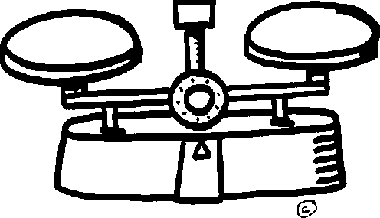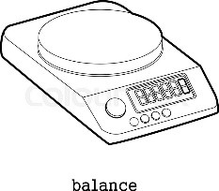

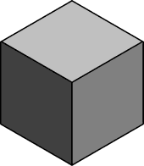
Volume (liquids)  The measure of how much space an obeject or substance occupies | Graduated cylinder (mL)  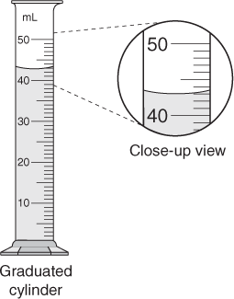
Volume (regular solids) | Use a ruler to measure the length, width, and height of the object.  Multiply- L x W x H  The units are cm3.
Volume (irregular solids) | Water displacement using a graduated cylinder  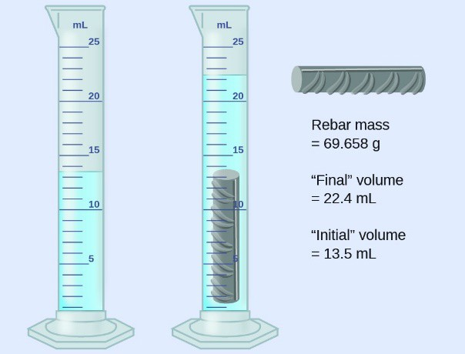
Magnetism | Is the object attracted to a magnet?  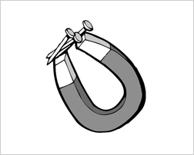
Temperature- the measure of average kinetic energy of the particles of an object or substance  Rub your hands together around the thermometer. Notice what happens to the reading on the thermometer. | Thermometer  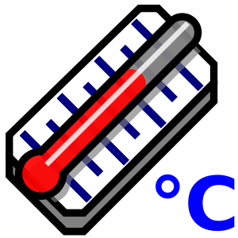
Insulator or conductor of thermal energy | Conductivity tester
Boiling, melting, and freezing points | Thermometer
State of matter (solid, liquid, or gas or plasma)  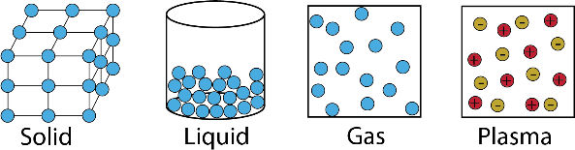 | Sense of sight and touch

Mixtures or solutions  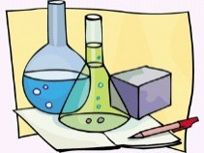 | Sense of sight; other separation techniques
Buoyancy  Objects float because they weigh less than the weight of the water they  displace. Objects sink because they weigh more than the weight of the water they displace.  Floating FG (weight of object) < FB (weight of water displaced).  Sinking is FG (weight of object) > FB (weight of water displaced). | Will it sink or float? https://www.youtube.com/watch?v=nMlXU97E- uQ&t=43s  Ships and buoyancy: Ships are massive in size, but because of the air inside them and their “V” shape, they weigh less than or equal to the weight of the water they displace.
Density is the amount of matter within a given amount of space.  Density = Mass (g)  Volume (cm3 or mL)  Density is measured in g/cm3 or g/mL. Archimedes is credited with discovering how to use density to identify substances. | Will it sink or float?
Solubility in water | Will it dissolve completely? 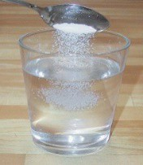
Brittleness | Is it easily broken?

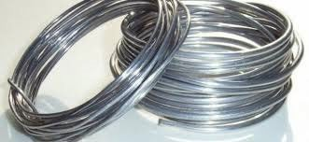
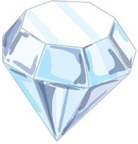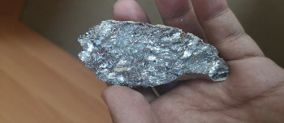
Hardness | Is it easily scratched?
Luster | Is it shiny or dull in color? Does it easily reflect light?
Viscosity | Does it pour quickly or slowly?  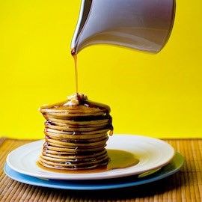
Malleability  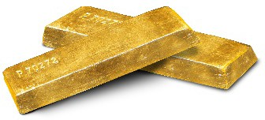 | Can be pounded into sheets
Ductility | Can be stretched or pulled into wires
Elasticity | How much can the object bend and return to its original shape?
Conductivity | Does it conduct heat or electricity well?

D. Chemical Properties
- Chemical properties are properties or characteristics of a pure substance that describes its ability to change into another substance. Chemical properties can only be observed during a reaction in which the chemical composition or identity of the substance is changed.

Some examples of chemical properties:
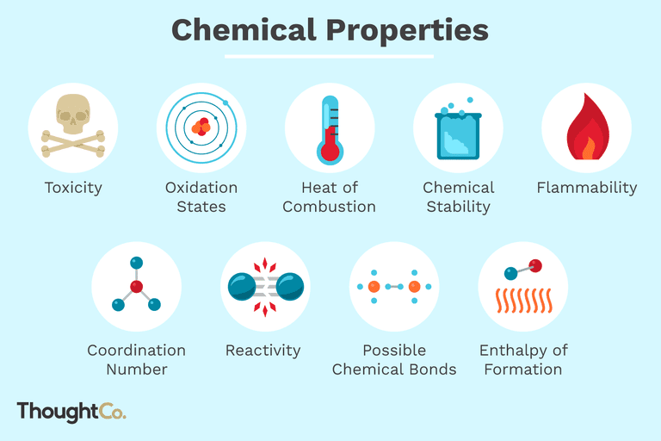

Note Interaction:
To the left are two garden trowels. Both were left out in the weather for several weeks. One became rusty and the other didn’t? Do you think these two trowels are made from the same metal? Why or why not? Use your knowledge or physical and chemical properties to explain your reasoning.
