1502
Young Hare by Albrecht Durer

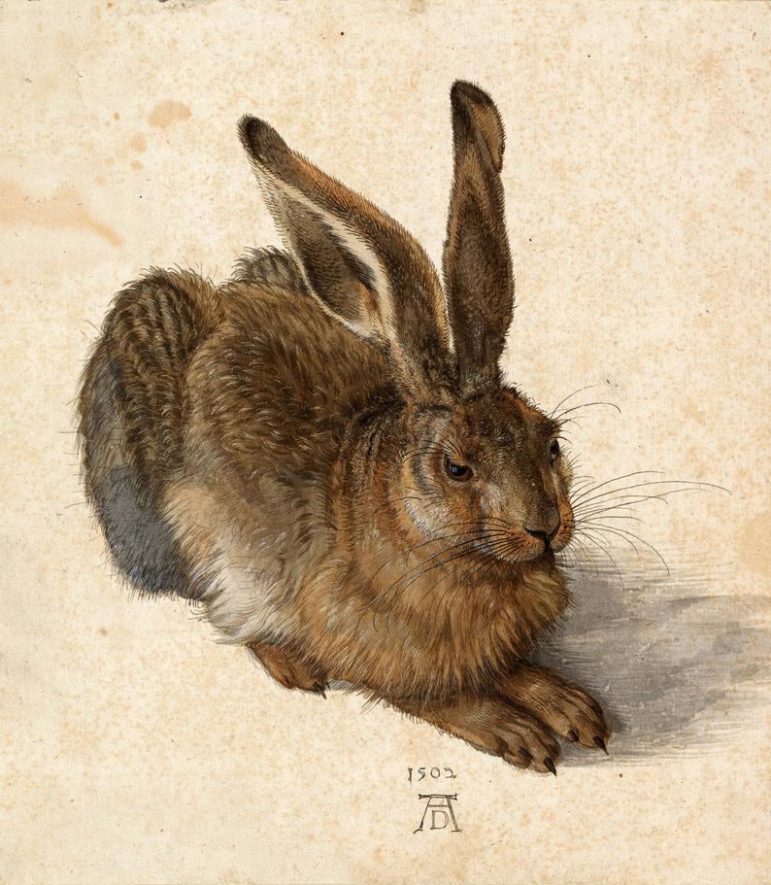
The incredible detail and care in this study of a small wild animal is a predecessor to the detailed scientific illustrations it has influenced and endures as an extremely accurate and sensitive depiction of one of nature's common creatures. It shows a hare in three-quarter view, its hind legs folded underneath its body, with the front legs slightly extended forwards. Although the work usually bears the title Young Hare, the animal can be identified as a mature wild hare.
Dürer's nature pieces are famously detailed. Young Hare is, however, not simply a scientific study of an animal. The work contains an innate tension, created by the contrast between the subject and its depiction: a hare is a notoriously restless animal, fleeing when approached too closely. The artist has captured the hare in a fleeting moment of stillness. The slight turn of its ear and the eye that's fixing the viewer, however, indicate that the animal has noticed us. Its hind legs are bent, ready to jump.
Whether the artist sketched a hare in the wild and completed the final piece with a dead specimen, or he kept a live animal in his studio is a question yet to be solved. The left eye reflects what seems to be a window. This has been taken as a clue that Dürer kept and painted the hare indoors. Adding a crossbar to the pupil of an eye is a recurring feature of Dürer's work and could simply be a technical method to create vitality in the eye. It could also be another testament to Dürer's meticulous attention to detail, of him capturing the reflection of his workshop window in his subject's eye. The prominent monogram and date indicate that the artist perceived the drawing as a complete work in its own right rather than a sketch.
Watercolor and gouache on paper - Albertina, Vienna
This is one example of his many sketches of nature: animals and plants. He is very famous for his drawing of ‘Praying Hands’.

Source: https://www.theartstory.org/artist/durer-albrecht/artworks/

