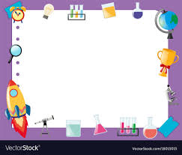
3rd Grade Supply List

1 3-ring binder
1 pack plastic dividers with folders
1 pack colored pencils
1 24-pack of crayons
2 packs of #2 pencils
1 highlighter
2 spiral or composition notebooks (wide ruled)
2 packs of notebook paper
3 glue sticks
1 pack of pencil top erasers

