MATH Assignments for the week of May 11
4.NBT.6 Standard: Illustrate and explain how to divide whole numbers using explanations, rectangular arrays, and area models.
Monday, May 11
Solve each part of the story.
Jack was excited to be helping his grandparents at their local farm market. He knew that it had to involve some math so he took a small notebook with him to work out any problems he had.
Jack and his grandpa picked 26 peppers. Grandma said to put them in baskets of 6. She said to put any leftover peppers in a bag by her purse.
Here is what Sam wrote in the notebook:
______ baskets

______ leftover

Grandma had been busy baking cookies while Jack and Grandpa were picking peppers. She made 37 chocolate chip cookies. She told Jack to put 4 cookies on each paper plate and she would wrap them in plastic. Jack divided to find out how many plates he would need. He wrote:
I need________ plates. There was _______leftover.

It was almost time for the customers to start arriving at the farm stand. Grandpa had 25 tomatoes and he put them in baskets of 3. Jack figured this is how many baskets of tomatoes there were:
_____ baskets

Jack hurried up and got the corn and carrots. Grandma brought out the heads of cabbage. Grandpa said, “We almost forgot the red beets. We have 29 of them. Jack, figure out how many baskets we will need if we sell them in groups of 4.”
___ baskets.

They were busy all day. Grandpa said that because Jack was such as good helper he could have all the quarters in the register. Jack counted 52 quarters. If there are 4 quarters in one dollar, how many dollars equal 52 quarters? Show the work.

If you were Jack, what would you buy?__________________________________________________________________________________________________________________________________________________________________________
Tuesday, May 12
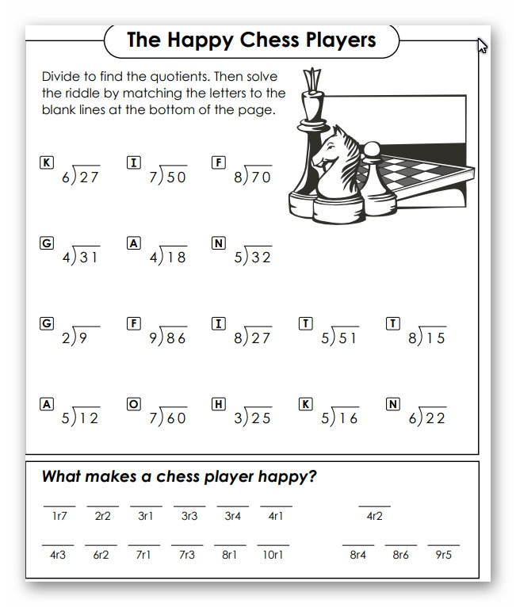

Wednesday, May 13
Problem of the day: Chloee had a bunch of pennies. She decided to count them and found out there were 48. She decided to stack them in groups of 5 because she was bored. How many stacks could she make?____________
I am going to attempt something that I have never done before. Teach long division without having students with me.
If you read the standard for division, it indicates the use of area models and rectangular arrays. Due to the circumstances this year, I won’t be able to do that. I will try to introduce the equation way to do long division.
If you have access to the internet, there are several resources that may help. One is KHAN ACADEMY Long Division. I also looked at YOUtube Division with a Remainder. It may be helpful too.
You may have noticed that there are several ways we write the division sign. The sign that looks like subtraction with a point on top and a point on the bottom is usually used for basic division facts with no remainder.
Long division uses a symbol that I cannot type on a computer. This is the best I can do: /-------------- .
If you don’t have the internet, I have step by step instructions on the next several pages for long division Bet you will say,” Now I know why they call it LONG.”

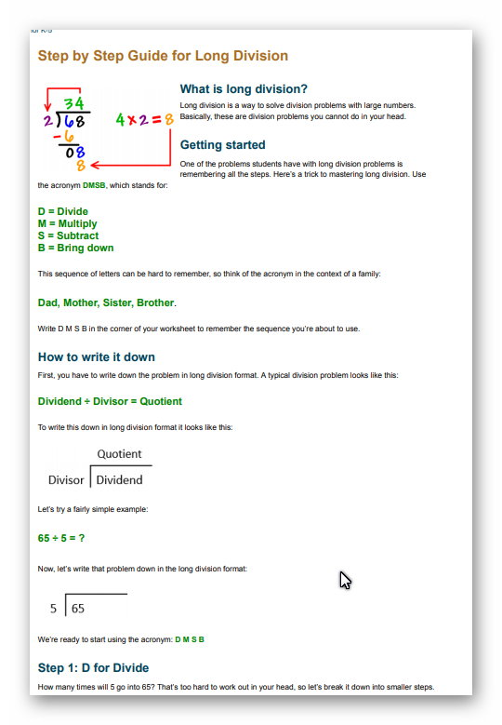

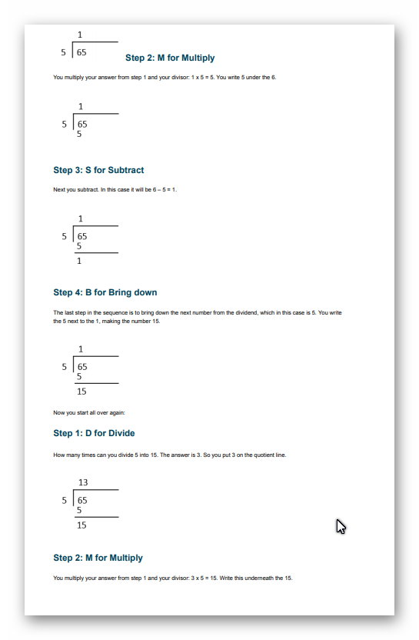

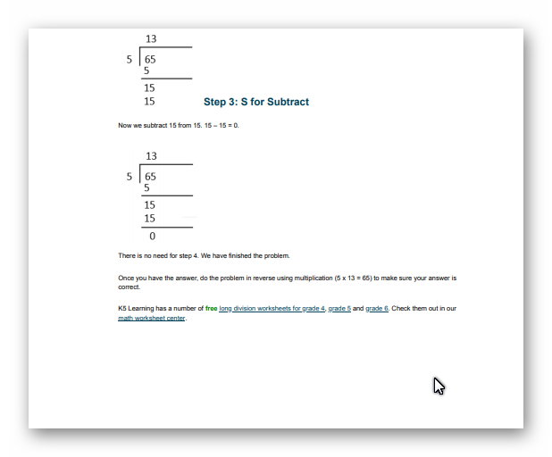

You can try a problem:
5/--------72 (72 divided by 5)

Thursday, May 14
The long division pattern is divide, multiply, subtraction, bring down, REPEAT
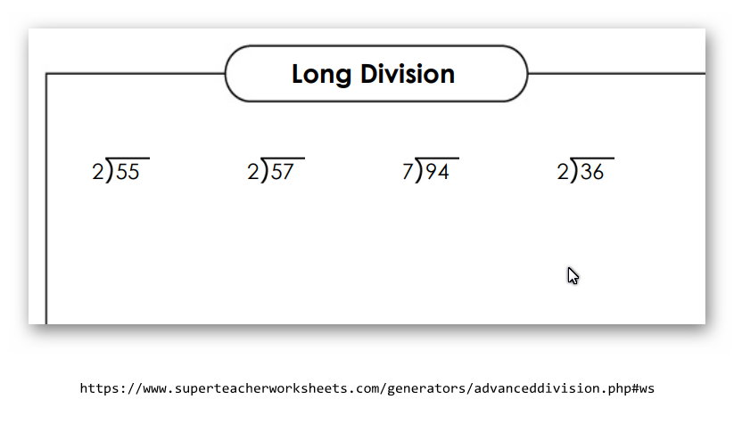

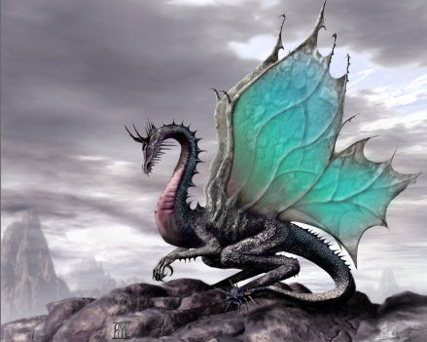

Friday, May 15

Here are 4 more problems. This has been a challenge for you , and I appreciate your effort.

