**[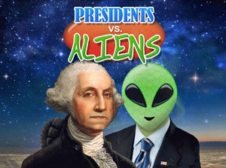](http://www.bestkidsapps.com/wp-content/uploads/2011/07/presidentsvsaliens.jpg)** [**Presidents vs. Aliens**](http://www.bestkidsapps.com/ages-9-12/presidents-vs-aliens/) (just got this one -- it's GREAT!): This is another app from Dan Russel Pinson (Stack the States guy) and is a winner. You earn Presidents by answering questions correctly and then fling your Presidents at the Aliens - how cool is that?  (Free)

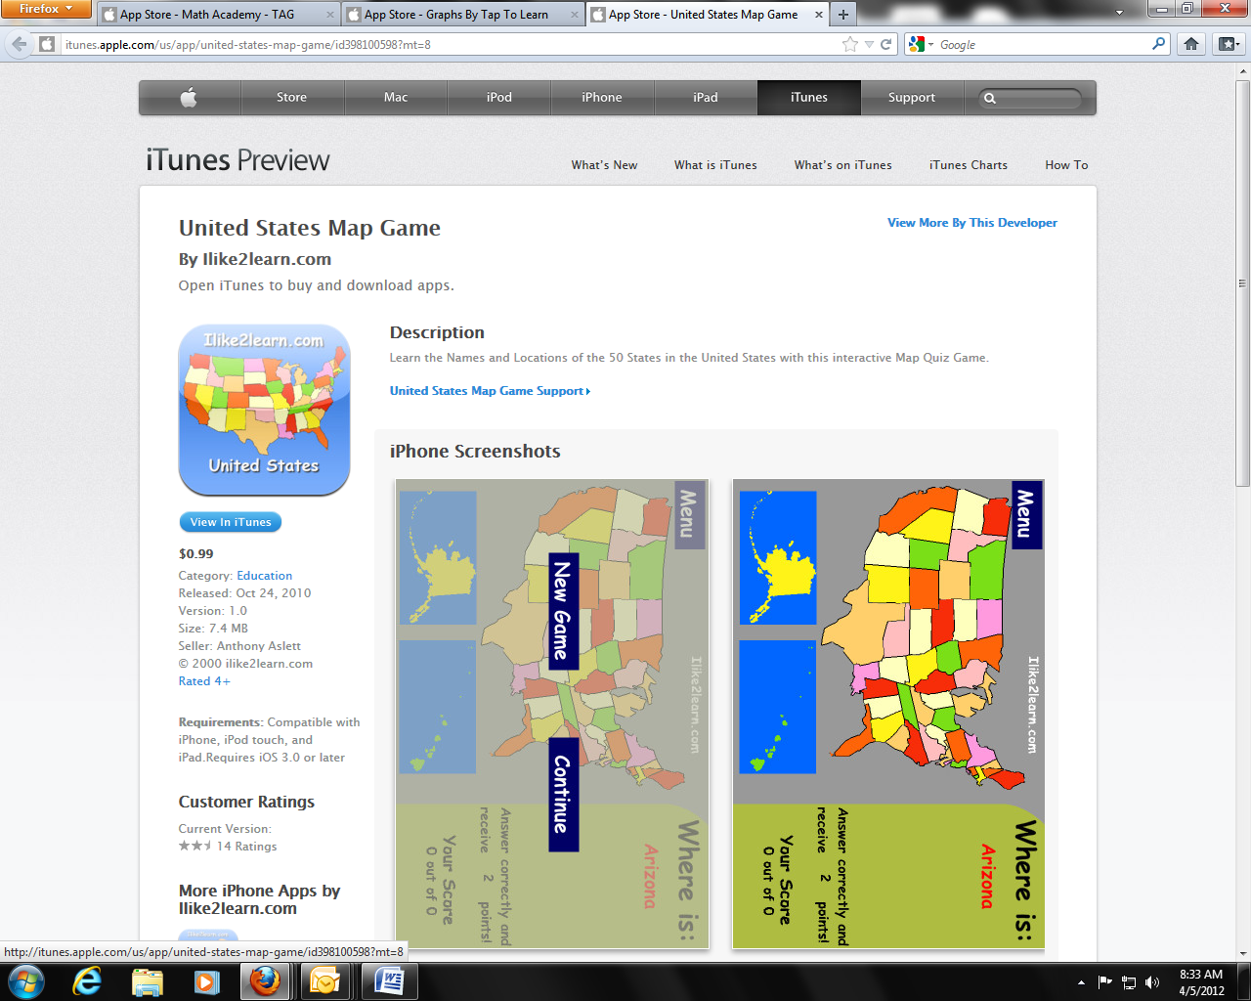**United Stated Map Game** (free) Learn the Names and Locations of the 50 States in the United States with this interactive Map Quiz Game.

[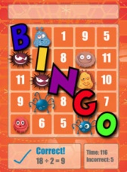](http://www.bestkidsapps.com/wp-content/uploads/2010/05/math-bingo.jpg)[**Math Bingo:**](http://itunes.apple.com/us/app/math-bingo/id371338715?mt=8) just like the name says - it's a BINGO game with math facts. The fun part, however, is that you earn BINGO bugs for speed and then can play Bingo Bug Bungee as a reward. I am hooked on this. .99

|  |
| --- |
|  |

**[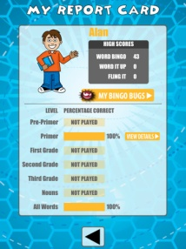](http://a3.mzstatic.com/us/r1000/035/Purple/87/97/ea/mzl.tgzfeqdx.480x480-75.jpg)**[**Word Bingo:**](http://itunes.apple.com/us/app/word-bingo/id406264088?mt=8) This is similar to Math Bingo. It is expanded, however, and you can even choose your grade level - very nice feature! ( .99)

|  |
| --- |
|  |

Use the iPad as an expensive mini whiteboard.

Install a painting app such as the free **Doodle Buddy.**

Students can then use the iPad to draw their answers to

questions as they would on amini-whiteboard, but with less

mess and no need for pens. The app can also be used in

MFL when doing description -iPad in pairs, one person

describes hair and eyes in the target language, the other

draws what they hear. (Free)

 **Socrative** ( you will need to download teacher version and students will use student version on either student Ipad or Smartphone) (**Free-just for a short time)**

Description

Socrative brings smart clickers, student response and ease of use to a whole new level. Be engaged for the entire class with educational exercises and games. See all your classmates’ ideas in real time and interact with the responses. Provide your instructor feedback on the lessons and how well you understand the material. Ask your own poll questions for the entire class or build a premade activity for your whole class. Have Fun!

--WORKS ON ANY DEVICE WITH A WEB BROWSER: Tablets, Smartphones & laptops (expect some types of blackberries)

MOST POPULAR ACTIVITIES:  
✔ Short Answer Questions  
✔ Space Race  
✔ Exit Tickets

✔ Quick Quiz  
✔ Multiple Choice

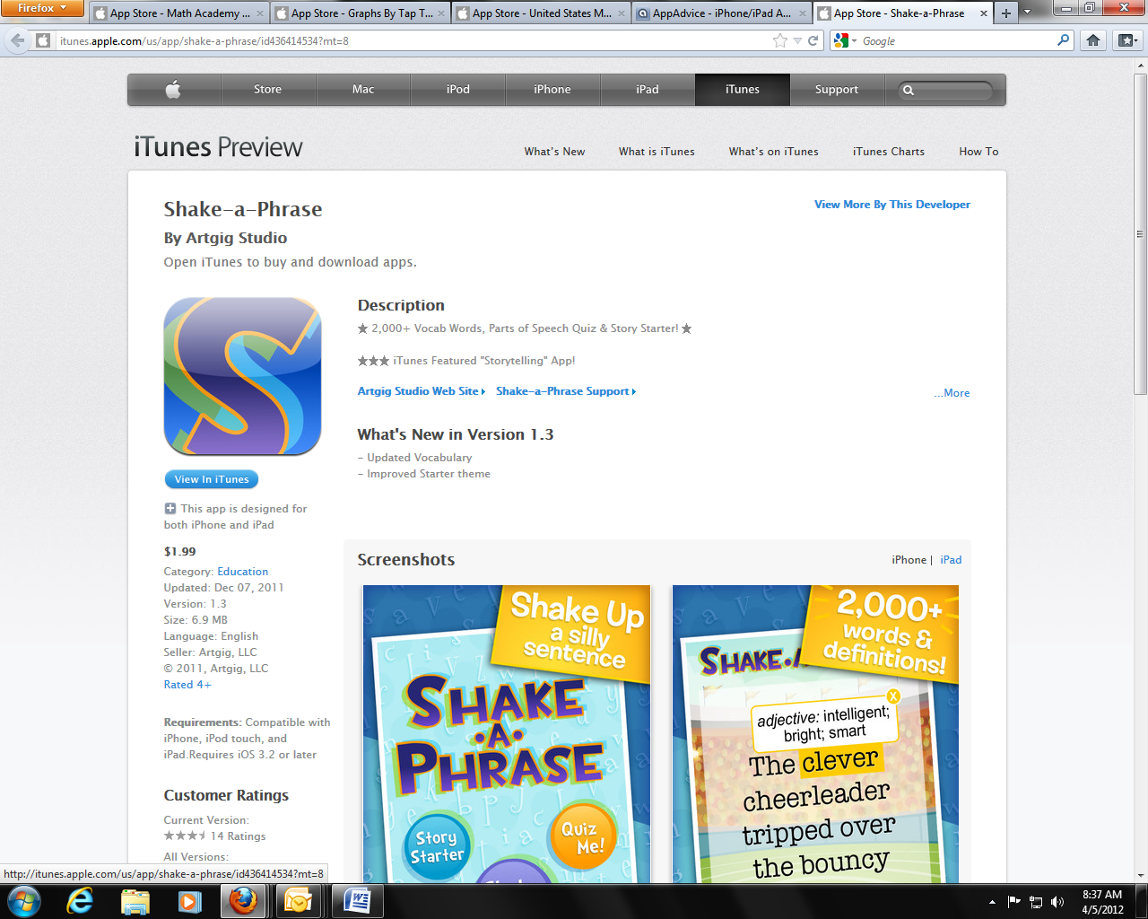**Shake a Phrase**  -Shake-a-Phrase is a fun language app that teaches vocabulary and parts of speech for ages 8+. Perfect for learning and laughing in the classroom or on-the-go, this lightweight app features over 2,000 words and definitions in 5 colorful and engaging themes. ($1.99)   
  
There are 3 ways to shake up a storm of wacky, funny sentences:  
  
• Shake It: creates a new random sentence every time you shake - great for discovering new words. Not sure what a word means? Just tap for definitions!  
  
• Story Starter: shake up the beginning of a story and let your imagination take over.  
  
• Quiz Me: test your skills with adjectives, verbs and nouns. Tap on the right words to get points and gain levels.

[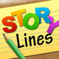](http://www.appolicious.com/games/apps/822996-storylines-root-one-inc)Do you remember playing the game 'Telephone' when you were little? You

**Story Lines:**The idea behind the game is very simple. The first player must come up with a sentence or phrase, and write it down. The next player must then illustrate that phrase to the best of his or her ability. The third player will then try to describe what is happening in the picture without seeing the original phrase, and so on, until everyone has a chance to contribute. Drawing skill is not a prerequisite for this game, and in fact, the more difficult it is to decipher the drawings, the sillier the results become. **Free**.r

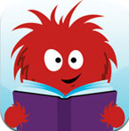[**Read Me Stories**](http://itunes.apple.com/us/app/read-me-stories-childrens/id362042422?mt=8): Read Me Stories offers a new book each day with illustrations and voices. Free

[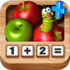](http://itunes.apple.com/us/app/adding-apples-hd/id464881662?mt=8&uo=2&partnerId=30&siteID=uIXydSSmUKA)[**Adding Apples**](http://click.linksynergy.com/fs-bin/stat?id=rm7r7jKp2P0&offerid=146261&type=3&subid=0&tmpid=1826&RD_PARM1=http%253A%252F%252Fitunes.apple.com%252Fus%252Fapp%252Fadding-apples%252Fid465950868%253Fmt%253D8%2526uo%253D4%2526partnerId%253D30) has a fairly simple interface – a wooden calculator with the numbers from 1-9, a chute that apples roll into, and a cheerful green worm to be your guide.  Your child is directed by the on-calculator worm to press any number button.  When she does, the corresponding number of apples rolls into the chute.  When another number is pressed (or the same number if you’re working on doubles) that quantity of apples – in another color – rolls into the chute. Free.

 **2x2=4**   
Advantages:  
-Two kinds of arithmetic operations: multiplication and division  
-A built-in multiplication table for learning  
-3 levels of the level of complexity(the speed of shooting at pirate is raising or lowering)  
-Two types for answer entering: by figures and by multiple choice  
-The history of already played games can be saved in order to trace the progress  
-The possibility to choose the range of the derived equations. Free

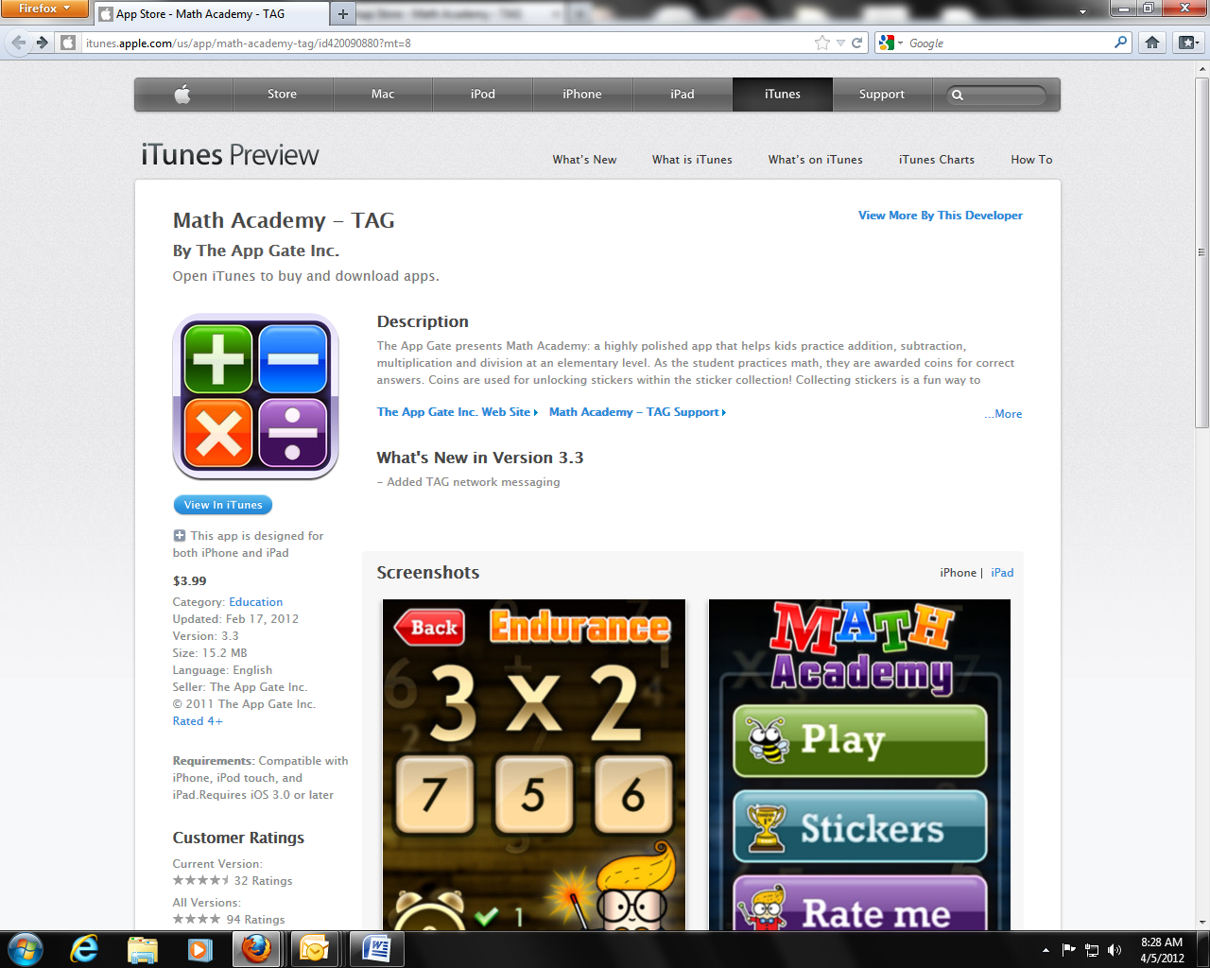**Math Academy** Math Academy ($3.99): a highly polished app that helps kids practice addition, subtraction, multiplication and division at an elementary level. As the student practices math, they are awarded coins for correct answers. Coins are used for unlocking stickers within the sticker collection! Collecting stickers is a fun way to encourage kids to keep practicing math!

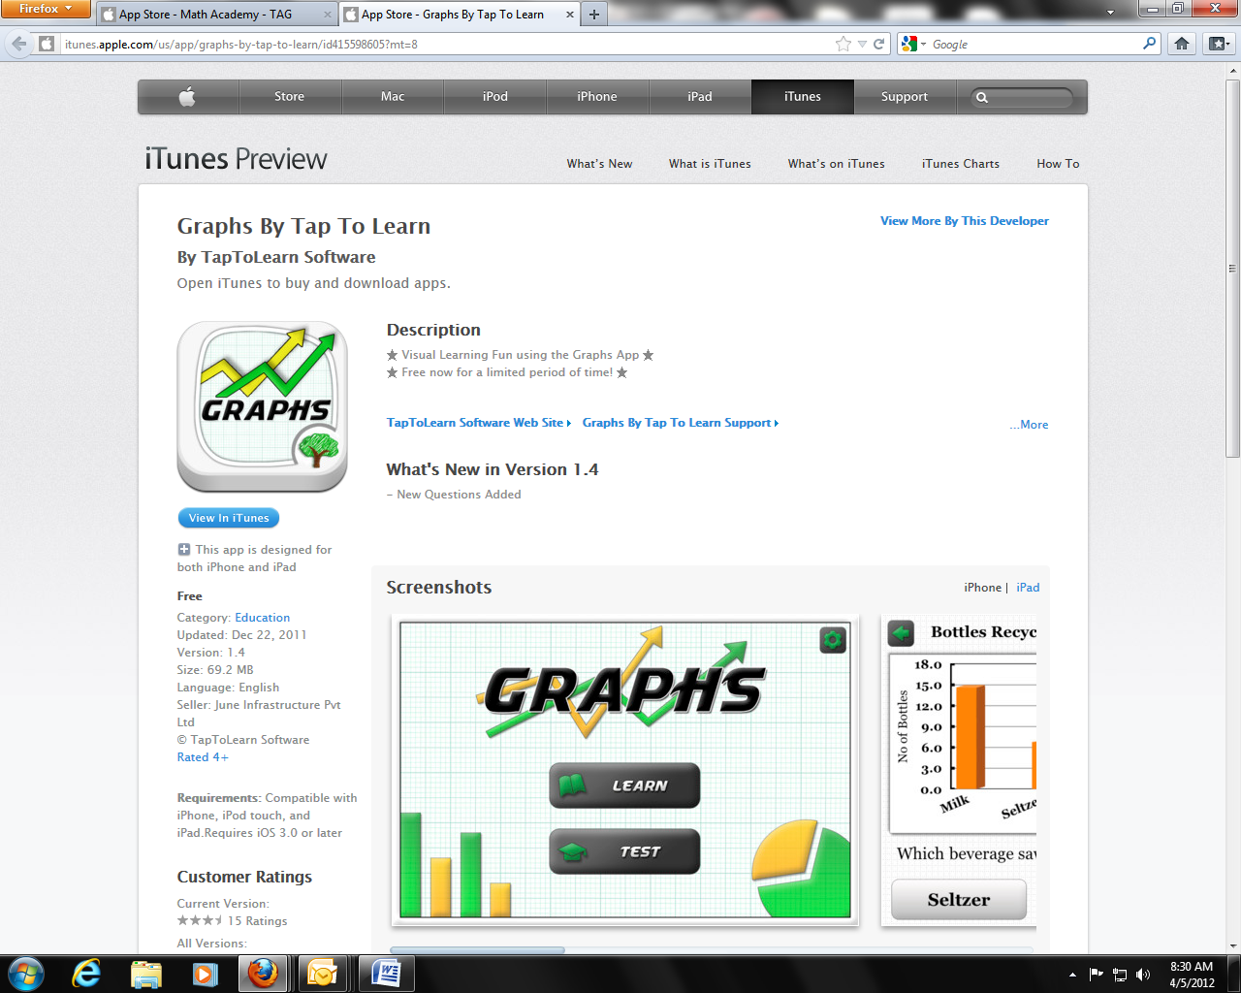**Graphs by Tap & Learn**  (Free) It serves as an excellent first guide and workbook to understand types of graphs including Line Graphs, Bar Graphs and Pie Charts. In addition to this, concepts such as Mean, Mode and Median are also explained in simple terms.

**Shopping APPs Websites:**

App Advice: <http://appadvice.com/appnn>

App Shopper: <http://appshopper.com/education/lets-name-things>

App Annie: <http://www.appannie.com/top/ipad/united-states/education/>

**App Websites:**

Christian Co.TIS Website: <http://www.christian.kyschools.us/webpages/tpelletier/ipads.cfm>

Apps By Subject (all grades):  
<http://www.apple.com/education/apps/>

Bloom's Taxonomy of Apps:  
<http://issuu.com/ktenkely/docs/lg_alpha?mode=window&backgroundColor=%23222222>

<http://www.ipadcurriculum.com/>

Apps for Middle School:  
<http://palmbeachschooltalk.com/groups/ipadpilot/wiki/ad829/>

<http://www.ipadinschools.com/ipad-apps-for-middle-school/>  
  
Apps for 9-12 Grade (all subjects):  
[http://cre8tiveduservices.pbworks.com/w/page/34819551/Scott-County-High-School-iPod-Training%29...just](https://pod51004.outlook.com/owa/redir.aspx?C=4rPbs77W1kmCrTYrCgmXp2NHJP2TaM4I-Ax8tcPUWHQPUY59SrtpPuhNn36axZpDRWno_K6YFJ8.&URL=http%3a%2f%2fcre8tiveduservices.pbworks.com%2fw%2fpage%2f34819551%2fScott-County-High-School-iPod-Training%2529...just)