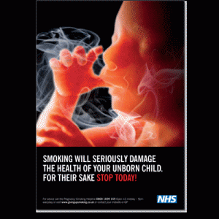
Tobacco smoke contains more than 4000 harmful chemicals, of which a number of them are known carcinogens in humans, whilst others are highly toxic and poisonous.
The chemicals that most affect the foetus and its healthy development are nicotine, tar and carbon monoxide, although arsenic, ammonia, hydrogen cyanide, formaldehyde and creosote are in no way good for the baby to inhale either.
When an expecting mother inhales tobacco smoke from a cigarette, some of the chemicals are exhaled immediately and leave the body, but others stay in the body and make their way into the placenta. The unborn child, as well as inhaling the mainstream smoke that the mother breathes in from the cigarette, which stays in her body, it may also inhale any secondhand smoke that is in the air. This would mean that the growing foetus would be negatively affected by two different types of smoke. Once the baby is born, it would no longer be affected by the mainstream smoke that the mother inhales, however if the mother continues to smoke, the child will suffer the effects of secondhand smoke and become a passive smoker itself.
The unborn child in the womb relies on the mother for its food, nutrients and oxygen in order to develop and grow healthily before the birth. The placenta is the tissue that connects the foetus to its mother and from where it receives all it needs for its correct development whilst it is in the mother's womb.
On smoking several things happen. Firstly, there is a reduced supply of oxygen, due to the increase of nicotine and carbon monoxide in the mother's bloodstream. This means that there is less oxygen available to the baby, as the harmful substances replace it. The baby will begin to move slower after the mother has smoked a cigarette and the baby's heart will have to work faster, as it tries to breathe in more oxygen. Consequently, its breathing and movement will be altered. In other words it will suffer unnecessary stress.
As well as a reduced amount of oxygen, the nicotine constricts the blood vessels in the mother's side of the placenta, thus preventing the blood supply, oxygen and the necessary amount of nutrients and food from reaching the baby, which will result in the slow growth of the foetus.
As a result the foetus will not develop or grow as well as it should and this can lead to the birth of a low-weight baby and all the risks and complications that this could entail. A low-weight baby is more likely to be placed in intensive care once it has been born.
Not only this, once the mother has given birth, she will cut off the supply of nicotine to her child and shortly the baby will begin to suffer the effects of nicotine withdrawal.
Even if the mother does not smoke but the baby is exposed to passive smoking from the father, the growth and development of the foetus can be affected.
http://www.helpwithsmoking.com/smoking-and-pregnancy/effects-on-foetus-pregnancy.php

