6th Grade Technology Applications
Assignment 3/30 to 4/2

- Watch the video for students using Google Classroom. It is also posted on my teacher page on the Lohn ISD website.
https://www.youtube.com/watch?v=qSxNLaWm74g

- There are a variety of tutorials on youtube for using Google Classroom so be sure to check them out.

- You can find the classroom icon under the 9 dot waffle in the upper right hand side of the google search engine.

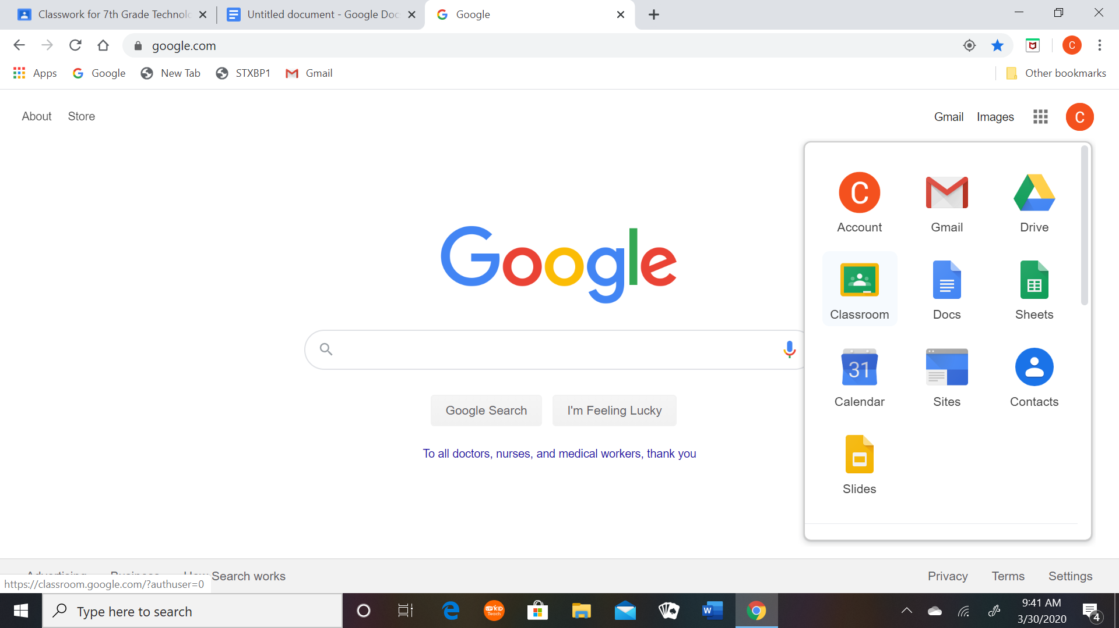

See the Assignment Below

- Your assignment this week is to create a google slides presentation that teaches a student how to use the Google Classroom. So you must research it well.

- You may use images and text. Be creative, thoughtful and thorough.

- Remember, in this context, you are the teacher.

- Provide at least 20 slides or more so look at details.

- You may include screenshots, but do not copy too much of any video. Originality counts!

Rubric for Grading

Accurate | Not Very  < 30 pts | Somewhat  30 - 40 pts | Very Accurate 50 pts
Thorough | Not Very  < 20 pts | Somewhat  20 - 28 pts | Very Thorough  30 pts
Creative or Original | Not Very  < 10 pts | Somewhat  10 - 18 pts | Very Creative  20 pts

