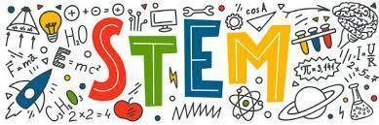
What is STEM?
It is the integration of Science, Technology, Engineering, and Mathematics. Students will learn to solve real world problems by using their knowledge of science, math, and robotics. They will learn computer programming to write a code for a robot to enhance their learning of grade level science and math content all while using their learned knowledge to solve a problem such as “How to Clean Polluted Water” or “Impact of Natural Disasters on Animals”. Students will learn to use the Engineering Design Process to design, create, and build structures to solve their problems. STEM is a class that requires all students to actively participate, be hands-on, and work with their team collaboratively.

