Technology Applications-6th Grade Assignment
Week May 11 – 15, 2020

- Go to typing.com on your computer or laptop and select student (no need to log in) Intermediate Lessons.
- Work your way through all of the Intermediate Lessons throughout the week. It will be a little harder on laptops to accomplish but will still be good practice.
- After going through all of the lessons and practice, do 2 different 5 minute – Intermediate tests.
- After each test take a screenshot of your test results (see directions for taking screenshot below).
- Email your screenshots to me at csnodgrass@lohnisd.net

Screenshot – take a screenshot by pressing the windows button and the PrtSc buttons at the same time. The screen should dim for a moment and then you can find the screenshot in your picture files as a picture. We will also discuss this in our Zoom Meeting on Wednesday.
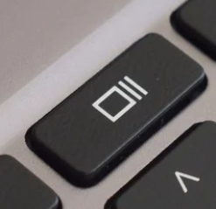
If using a chromebook - Hold down the Ctrl + Switch window keys to capture a full screenshot. Or, Hold down the Ctrl + Shift + Switch window keys to capture a partial screenshot. The Switch window key is at the top of keyboard. See the picture.

You can find the picture in files.

