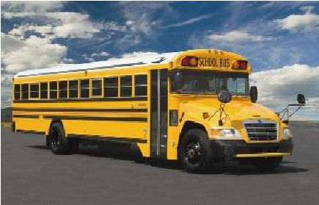
Mobile County
Public Schools

Summer Internship
Title:
Mechanic: Auto, Bus, Truck
Location:
Mobile, AL
Department: Transportation Department Compensation: $7.25
Duration: June 1, 2020- June 26, 2020 Number of Vacancies: 2 Time Requirements: Part Time

DUTIES
THE DUTIES INCLUDE BUT ARE NOT LIMITED TO:
- Repairs gas and Diesel engines.
- Repairs and exchanges transmissions.
- Repairs and exchanges differentials.
- Inspects buses.
- Repairs Electrical and Ignition system.
- Changes Oil, filter, and chassis lubrication.
- Other duties as assigned.

QUALIFICATIONS
- Must be able to read and understand all written materials, work orders, and shop manuals.
- Must be able to complete all paper work pertaining to job.
- Must be able to use and understand Digital Multi-meter.
- Must be able to read and understand a Wiring Schematic.
- Must be willing and physically able to perform any and all duties assigned while on duty.
- Will be expected to achieve and maintain average production of peers.
- Must have a minimum 3.2 GPA
Pay Schedule
You will get paid at the end of the Internship.

